A Brief Introduction to Species Distribution Modeling for Conservation Educators and Practitioners

Synthesis

Matthew E. Aiello-Lammensi, Andrea Pazii, Bethany A. Johnsoniii, Mary E. Blairiv , and Richard G. Pearsonv

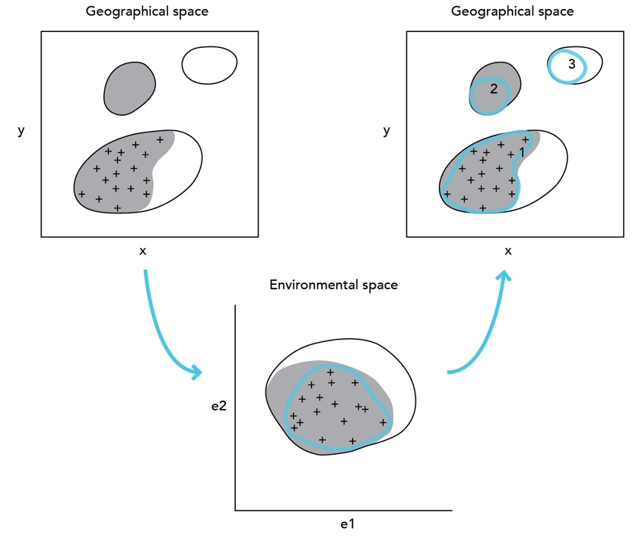

Abstract

This synthesis is an updated and condensed version of the original, "Species’ Distribution Modeling for Conservation Educators and Practitioners" synthesis (Pearson 2008). References have been updated and the introduction and framing have been streamlined to reflect recent developments in the field, including further emphasis on machine learning approaches to species distribution modeling.

This Synthesis is an update of “Pearson, R.G. 2008. Species’ Distribution Modeling for Conservation Educators and Practitioners. Synthesis. American Museum of Natural History. Available at https://ncep.amnh.org.”

This update is a condensed version of the original, with updated references, and a streamlined introduction and framing to reflect recent developments in the field, and especially to provide further emphasis on machine learning approaches to species distribution modeling.

Author contributions: Aiello-Lammens led the update. Paz, Johnson, and Blair contributed to the update. Pearson wrote the original version.

Reproduction of this material is authorized by the recipient institution for non-profit/non-commercial educational use and distribution to students enrolled in course work at the institution. Distribution may be made by photocopying or via the institution's intranet restricted to enrolled students. Recipient agrees not to make commercial use, such as, without limitation, in publications distributed by a commercial publisher, without the prior express written consent of the American Museum of Natural History.

All reproduction or distribution must provide full citation of the original work and provide a copyright notice as follows:

"Copyright 2023, by the authors of the material, with license for use granted to the Center for Biodiversity and Conservation of the American Museum of Natural History. All rights reserved.”

Any opinions, findings and conclusions, or recommendations expressed in this material are those of the authors and do not necessarily reflect the views of the American Museum of Natural History.

Table of contents

Learning objectives 4
Introduction 4
What is a species distribution model? 4
What data are needed to build an SDM? 5
Theoretical framework 10
Geographical versus environmental space 10
Estimating niches and distributions 13
Uses of species distribution models 17
References 19

A Brief Introduction to Species Distribution Modeling for Conservation Educators and Practitioners

Synthesis

Learning objectives

Through use of this synthesis, teachers will enable students to:
- Identify and describe important theoretical underpinnings of species distribution models.
- Identify key components of distribution models, including appropriate data and methods / algorithms.
- Be prepared to apply algorithms to train a species distribution model and test its predictive performance.
- Identify applications of distribution models in addressing a range of conservation questions.

Introduction

Predicting species’ distributions has become an important component of conservation planning in recent years, and a wide variety of modeling techniques have been developed for this purpose (Guisan and Thuiller 2005; Elith and Leathwick 2009; Peterson et al. 2011). These models commonly utilize associations between environmental variables and known species’ occurrence records to identify environmental conditions within which populations can be maintained. The spatial distribution of environments that are suitable for the species can then be estimated across a study region. This approach has proven valuable for generating biogeographical information that can be applied across a broad range of fields, including conservation biology, ecology and evolutionary biology. This synthesis aims to provide an overview of the theory and key components of species distribution modeling. Through use of the synthesis, teachers will enable students to understand the theoretical basis of distribution models, understand the techniques and steps required to run models using a variety of approaches, test the predictive ability of models, and apply the models to address a range of questions.

What is a species distribution model?

A common strategy for estimating the actual or potential geographic distribution of a species is to characterize the environmental conditions that are suitable for the species, and to then identify where suitable environments are distributed in space. For example, if we are interested in modeling the distribution of a plant that is known to thrive in wet clay soils, then simply identifying locations with clay soils and high precipitation can generate an estimate of the species’ distribution. There are a number of reasons why the species may not actually occupy all suitable sites (e.g., geographic barriers that limit dispersal, competition from other species), which we will discuss later. However, this is the fundamental strategy common to most species distribution models (SDMs).

The environmental conditions that are suitable for a species may be characterized using either a mechanistic or a correlative approach. Mechanistic models aim to incorporate physiologically limiting mechanisms in a species’ tolerance to environmental conditions (Kearney and Porter 2009). For example, (Chuine and Beaubien 2001) modeled distributions of North American tree species by estimating responses to environmental variables (including mean daily temperature, daily precipitation, and night length) using mechanistic models of factors including frost injury, phenology, and reproductive success. Such mechanistic models require detailed understanding of the physiological response of species to environmental factors and are therefore difficult to develop for all but the most well understood species.

Correlative models aim to estimate the environmental conditions that are suitable for a species by associating known species’ occurrence records with suites of environmental variables that can reasonably be expected to affect the species’ physiology and probability of persistence. The central premise of this approach is that the observed distribution of a species provides useful information as to the environmental requirements of that species. For example, we may assume that our plant species of interest favors wet clay soils because it has been observed growing in these soils. The limitations of this approach are discussed later in the synthesis, but it has been demonstrated that this method can yield valuable biogeographical information (e.g., Raxworthy et al. 2003; Bourg et al. 2005). Since spatially explicit occurrence records are available for a large number of species, the vast majority of species distribution models are correlative. The correlative approach to distribution modeling is the focus of this synthesis.

What data are needed to build an SDM?

The principal steps required to build and validate a correlative species distribution model are outlined in Figure 1. Two types of model input data are needed: 1) known species’ occurrence records; and 2) a suite of environmental variables. “Raw” environmental variables, such as daily precipitation records collected from weather stations, are often processed to generate model inputs that are thought to have a direct physiological role in limiting the ability of the species to survive (see Nix 1986 for early examples of such processing). Another important advancement involved spatial interpolation of these bioclimate factors (a brief history of these processes can be found in Booth et al. 2014). Presently there are several environmental data sets focusing on bioclimatic variables that are readily available (e.g., CliMond - Kriticos et al. 2011; WorldClim 2.0 - Fick and Hijmans 2017; ENVIREM - Title and Bemmels 2018). Additionally, environmental variables derived from remote sensing products are increasingly becoming available and being applied at local (e.g., Pasetto et al. 2018), regional (e.g., Paz et al. 2022), and global spatial scales (e.g., Deblauwe et al. 2016). Importantly, these remote-sensed environmental data are allowing researchers to move beyond relationships between presence and climate conditions only, which has been the dominant approach for many years.

The species occurrence records and environmental variables are entered into an algorithm that aims to identify environmental conditions that are associated with species occurrence. If just one or two environmental variables were used, then this task would be relatively straightforward. For example, we may readily discover that our plant species has only been recorded at localities where mean monthly precipitation is above 60mm and soil clay content is above 40%. In practice, we usually seek algorithms that are able to integrate more than two environmental variables, since species are in reality likely to respond to multiple factors. Algorithms that can incorporate interactions among variables are also preferable (Elith et al. 2006; Franklin 2010; Valavi et al. 2022). For example, a more accurate description of our plant’s requirements may be that it can occur at localities with mean monthly precipitation between 60mm and 70mm if soil clay content is above 60%, and in wetter areas (>70mm) if clay content is as low as 40%.

Multiple modeling algorithms are available to determine relationships between species presence and environmental conditions (see Valavi et al. 2022 for one overview of multiple methods). Possible appropriate algorithms include those based on foundational frequentist statistics (e.g., logistic regression, generalized linear models, and generalized additive models), Bayesian statistics (e.g., hierarchical Bayesian models), or machine learning principles (e.g., Maxent, random forest, and artificial neural networks; see Box 1 for more information on machine learning). Depending on the method used, various decisions and tests will need to be made to ensure the algorithm gives optimal results. For example, a suitable “regularization” parameter will need to be selected if applying the Maxent method (see Phillips et al. 2006; Elith et al. 2010; Merow et al. 2013; and the Wallace - Module Guidance for the Maxent module in software described in Kass et al. 2023), or the degrees of freedom must be selected if running a generalized additive model (see Guisan et al. 2002). The relative importance and/or correlation of alternative environmental predictor variables may also be assessed at this stage so as to select which variables are used in the final model.

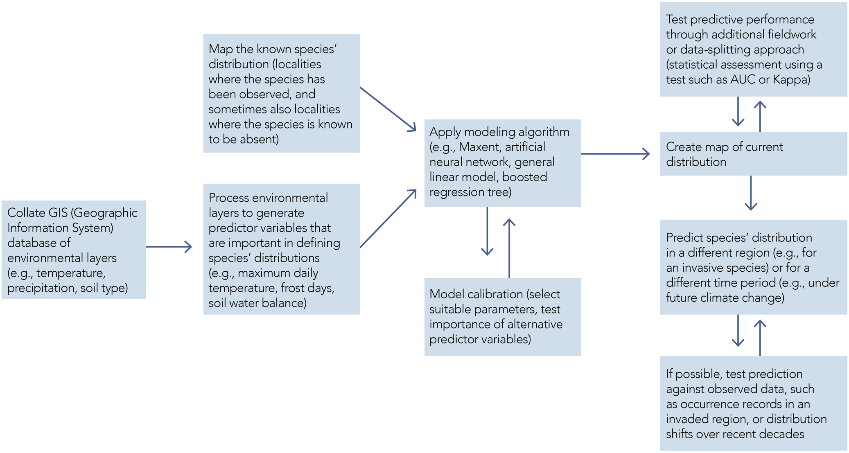

Figure 1. Flow diagram detailing the main steps required for building and validating a correlative species distribution model.

Box 1. Machine learning algorithms

Machine learning algorithms are increasingly being applied to species distribution modeling (Lucas 2014). This is primarily due to the abilities of many machine learning algorithms to fit complex and non-linear relationships that are common in natural systems, and because computational advances have made these algorithms fast and efficient (Olden et al. 2008; Peters et al. 2014).

At a high level, machine learning algorithms can be divided into three categories: supervised learning, unsupervised learning, and reinforcement learning. Supervised learning involves training a model using input data associated with known outputs (e.g., climatic and/or environmental conditions at known locations of species presence or absence). Unsupervised learning, on the other hand, involves finding patterns in data without known outcomes (i.e., no response variable is identified). Reinforcement learning involves training a model to make decisions based on feedback from data collected from a dynamic system or environment. As of 2023, machine learning approaches using supervised learning were most commonly applied in SDMs (e.g., Maxent, random forests, support vector machine, artificial neural networks; Lucas 2014; Peters et al. 2014), though some unsupervised learning algorithms are also used (e.g., k-means clustering, Guassian mixture models; Christin et al. 2019). While reinforcement algorithms are beginning to be applied in conservation sciences (e.g., Lapeyrolerie et al. 2022), we know of no applications to SDMs at this time.

The success of machine learning algorithms depends on the quality and quantity of the training data. To train a model, the data is split into a training set and a testing set, where the training set is used to train the model, and the testing set is used to evaluate its performance on unseen data. There are several approaches an analyst can take to splitting the data, which are discussed in the model evaluation section below.

After running a modeling algorithm, the resulting estimated mathematical relationships between species occurrence and environmental conditions can be used to construct a

After running a modeling algorithm, the resulting estimated mathematical relationships between species occurrence and environmental conditions can be used to construct a map showing the predicted species’ distribution. The ability of the model to predict the known species’ distribution should be evaluated, or tested, at this stage. A YouTube video providing an overview of model evaluation is available here: ENM2020 - W22T1 - Evaluation Overview; https://youtu.be/jG5bcr3jzmA. A set of species occurrence records that have not previously been used in the modeling should be used as independent testing data. The ability of the model to predict the independent data is assessed using a suitable test statistic. Different approaches to generating test datasets and alternative statistical tests are discussed in detail in Pearson’s Species’ Distribution Modeling for Conservation Educators and Practitioners synthesis (2008, Section 5; available from the NCEP module collection at https://ncep.amnh.org). Since a number of modeling algorithms predict a continuous distribution of environmental suitability (i.e., a prediction between 0 and 1, as opposed to a binary prediction of “suitable” or “unsuitable”), it is sometimes useful to convert model output into a prediction of suitable (1) or unsuitable (0). This is a necessary step before applying many test statistics; thus, methods for setting a threshold probability, above which the species is predicted as present, are also outlined in Section 5, with additional information available in Liu et al. 2005 and Liu et al. 2016.

Once these steps have been completed, and if model validation is successful, the model can be used to predict species’ occurrence in areas where the distribution is unknown. Thus, a set of environmental variables for the area of interest is input into the model and the suitability of conditions at a given locality is predicted. In many cases the model is used to “fill the gaps” around known occurrences (e.g., Anderson et al. 2002; Ferrier et al. 2002). In other cases, the model may be used to predict species’ distributions in new regions (e.g., to study invasion potential, for review see Peterson 2003; Srivastava 2019) or for a different time period (e.g., to estimate the potential impacts of future climate change, for review see Anderson 2013). Ideally, model predictions into different regions or different time periods should be tested against observed data; for example, Thuiller et al. 2005 tested predictions of invasion potential using occurrence records from the invaded distribution, whilst Araújo et al. 2005a tested predictions of distribution shifts under climate change using observed records from different decades.

This modeling approach has been variously termed “species distribution,” “ecological niche,” “environmental niche,” “habitat suitability,” and “bioclimate envelope” modeling. Use of the term “species distribution modeling” is widespread but it should be noted that the term is somewhat misleading since it is actually the distribution of suitable environments that is being modeled, rather than the species’ distribution per se. Regardless of the name used, the basic modeling process is essentially the same and the theoretical underpinnings of the models are similar. It is essential that these theoretical underpinnings are properly understood in order to interpret model outputs accurately. The following section describes this theoretical framework.

Theoretical framework

This section outlines some of the fundamental concepts that are crucial for understanding how species distribution models work, what types of questions they are suitable for addressing, and how model output should be interpreted.

Geographical versus environmental space

We are used to thinking about the occurrence of species in geographical space; that is, the species’ distribution as plotted on a map. To understand species distribution models it is important to also think about species occurring in environmental space, which is a conceptual space defined by the environmental variables to which the species responds. The concept of environmental space has its foundations in ecological niche theory. The term “niche” has a long and varied history of use in ecology (Chase and Leibold 2003), but the definition proposed by Hutchinson (1957) is most useful in the current context. Hutchinson defined the fundamental niche of a species as the set of environmental conditions within which a species can survive and persist. The fundamental niche may be thought of as an “n-dimensional hypervolume,” every point in which corresponds to a state of the environment that would permit the species to exist indefinitely (Hutchinson 1957, p. 416). It is the axes of this n-dimensional hypervolume that define environmental space.

Visualizing a species’ distribution in both geographical and environmental space helps us to define some basic concepts that are crucial for species distribution modeling (Figure 2). Notice that the observed localities constitute all that is known about the species’ actual distribution; the species is likely to occur in other areas in which it has not yet been detected (e.g., Figure 2, area A). If the actual distribution is plotted in environmental space then we identify that part of environmental space that is occupied by the species, which we can define as the occupied niche.

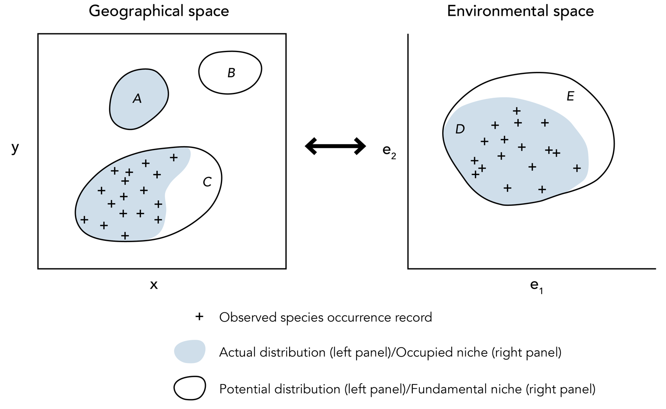
Figure 2. Illustration of the relationship between a hypothetical species’ distribution in geographical space and environmental space. Geographical space refers to spatial location as commonly referenced using x and y coordinates. Environmental space refers to Hutchinson’s n-dimensional niche, illustrated here for simplicity in only two dimensions (defined by two environmental factors, e₁ and e₂). Crosses represent observed species occurrence records. Grey shading in geographical space represents the species’ actual distribution (i.e., those areas that are truly occupied by the species). Notice that some areas of actual distribution may be unknown (e.g., area A is occupied but the species has not been detected there). The grey area in environmental space represents that part of the niche that is occupied by the species: the occupied niche. Again, notice that the observed occurrence records may not identify the full extent of the occupied niche (e.g., the shaded area immediately around label D does not include any known localities). The solid line in environmental space depicts the species’ fundamental niche, which represents the full range of abiotic conditions within which the species is viable. In geographical space, the solid lines depict areas with abiotic conditions that fall within the fundamental niche; this is the species’ potential distribution. Some regions of the potential distribution may not be inhabited by the species due to biotic interactions or dispersal limitations. For example, area B is environmentally suitable for the species, but is not part of the actual distribution, perhaps because the species has been unable to disperse across unsuitable environments to reach this area. Similarly, the non-shaded area around label C is within the species’ potential distribution, but is not inhabited, perhaps due to competition from another species. Thus, the non-shaded area around label E identifies those parts of the fundamental niche that are unoccupied, for example due to biotic interactions or geographical constraints on species dispersal.

The distinction between the occupied niche and the fundamental niche is similar, but not identical, to Hutchinson’s (1957) distinction between the realized niche and the fundamental niche. With reference to the case of two species utilizing a common resource, Hutchinson described the realized niche as comprising that portion of the fundamental niche from which a species is not excluded due to biotic competition. The definition of the occupied niche used in this synthesis broadens this concept to include geographical and historical constraints resulting from a species’ limited ability to reach or re-occupy all suitable areas, along with biotic interactions of all forms (competition, predation, symbiosis, and parasitism). Thus, the occupied niche reflects all constraints imposed on the actual distribution, including spatial constraints due to limited dispersal ability, and multiple interactions with other organisms.

If the environmental conditions encapsulated within the fundamental niche are plotted in geographical space then we have the potential distribution. Notice that some regions of the potential distribution may not be inhabited by the species (Figure 2, areas B and C), either because the species is excluded from the area by biotic interactions (e.g., presence of a competitor or absence of a food source), because the species has not dispersed into the area (e.g., there is a geographic barrier to dispersal, such as a mountain range, or there has been insufficient time for dispersal), or because the species has been extirpated from the area (e.g., due to human modification of the landscape).

Before we go on to discuss how these concepts are used in distribution modeling, it is important to appreciate that the environmental variables used in a distribution model are unlikely to define all possible dimensions of environmental space. Hutchinson originally proposed that all variables, “both physical and biological” (1957, p. 416), are required to define the fundamental niche. However, the variables available for modeling are likely to represent only a subset of possible environmental factors that influence the distribution of the species. Variables used in modeling most commonly describe the physical environment (e.g., temperature, precipitation, soil type), though aspects of the biological environment are sometimes incorporated (e.g., Araújo and Luoto 2007; Heikkinen et al. 2007). However, the distinction between biotic and abiotic variables is often problematic; for example, land cover type is likely to incorporate both abiotic (e.g., urban) and biotic (e.g., deciduous forest) classes.

Another important factor that we must be aware of is source-sink dynamics, which may cause a species to be observed in unsuitable environments. “Source-sink” refers to the situation whereby an area (the “sink”) may not provide the necessary environmental conditions to support a viable population, yet may be frequently visited by individuals that have dispersed from a nearby area that does support a viable population (the “source”). In this situation, species occurrence may be recorded in sink areas that do not represent suitable habitat, meaning that the species is present outside its fundamental niche (Pulliam 2000). We can logically expect this situation to occur most frequently in species with high dispersal ability, such as birds. In such cases it is useful to only utilize records for modeling that are known to be from breeding distributions, rather than migrating individuals. Because correlative species distribution models utilize observed species occurrence records to identify suitable habitat, inclusion of occurrence localities from sink populations is problematic. However, it is often assumed that observations from source areas will be much more frequent than observations from sink areas, so this source of potential error is commonly overlooked.

One more thing to be aware of before we move on is that some studies explicitly aim to only investigate one part of the fundamental niche, by using a limited set of predictor variables. For example, it is common when investigating the potential impacts of future climate change to focus only on how climate variables impact species’ distributions. A species’ niche defined only in terms of climate variables may be termed the climatic niche (Pearson and Dawson 2003), which represents the climatic conditions that are suitable for species existence. An approximation of the climatic niche may then be mapped in geographical space, giving what is commonly termed the bioclimate envelope (Huntley et al. 1995; Pearson and Dawson 2003).

Estimating niches and distributions

Let us now consider the extent to which species distribution models can be used to estimate the niche and distribution of a species. We will assume in this section that the chosen model algorithm is excellent at defining the relationship between observed occurrence localities and environmental variables; this will enable us to focus on understanding the ecological assumptions underlying distribution models.

Let us first ask what the aim of the modeling is: what element of a species’ distribution are we trying to estimate? There are many potential uses of the approach (Table 1) and these require modeling either the actual distribution or the potential distribution. For example, if a model is being used with the purpose of selecting sites that should be given high conservation priority, then modeling the actual distribution will be the aim (since there would be less priority given to conserving sites where the environment is suitable for the species, but the species is not present). In contrast, if the purpose is to identify sites that may be suitable for the reintroduction of an endangered species, then modeling the potential distribution is an appropriate aim. We will now consider the degree to which alternative aims are achievable using the species distribution modeling approach.

Table 1. Some published uses of species distribution models in conservation biology (Based in part on Guisan and Thuiller 2005).
Type of use | Example reference(s)
Guiding field surveys to find populations of known species | Bourg et al. 2005; Guisan et al. 2006
Guiding field surveys to accelerate the discovery of unknown species | Raxworthy et al. 2003
Projecting potential impacts of climate change | For review see Stanton et al. 2015; Blair et al. 2022
Predicting species’ invasion | Higgins et al. 1999; Thuiller et al. 2005; Barbosa et al. 2012
Exploring speciation mechanisms | Graham et al. 2004; Kozak and Wiens 2006; Musher et al. 2020
Supporting conservation prioritization and reserve selection | Villero et al. 2017
Species delimitation | Raxworthy et al. 2007; Bett et al. 2012
Assessing the impacts of land cover change on species’ distributions | Gavrutenko et al. 2021
Testing ecological theory | Anderson et al. 2002; Graham et al. 2006
Comparing paleodistributions and phylogeography | Hugall et al. 2002; Musher et al. 2020
Guiding reintroduction or re-establishment of endangered species | Pearce and Lindenmayer 1998; Trinh-Dinh et al. 2022
Assessing disease risk | Peterson et al. 2006, 2007
Assessing ecosystem services | Manhães et al. 2018

Correlative species distribution models rely on observed occurrence records for providing information on the niche and distribution of a species. Two key factors are important when considering the degree to which observed species occurrence records can be used to estimate the niche and distribution of a species:

- The degree to which the species is at “equilibrium” with current environmental conditions. A species is said to be at equilibrium with the physical environment if it occurs in all suitable areas, while being absent from all unsuitable areas. The degree of equilibrium depends both on biotic interactions (for example, competitive exclusion from an area) and dispersal ability (organisms with higher dispersal ability are expected to be closer to equilibrium than organisms with lower dispersal ability; Araújo et al. 2005b). When using the concept of “equilibrium” we should remember that species distributions change over time, so the term should not be used to imply stasis. However, the concept is useful for us here to help understand that some species are more likely than others to occupy areas that are abiotically suitable.
- The extent to which observed occurrence records provide a sample of the environmental space occupied by the species. In cases where very few occurrence records are available, perhaps due to limited survey effort (Anderson and Martı́nez-Meyer 2004) or low probability of detection (Pearson et al. 2007), the available records are unlikely to provide a sufficient sample to enable the full range of environmental conditions occupied by the species to be identified. In other cases, surveys may provide extensive occurrence records that provide an accurate picture as to the environments inhabited by a species in a particular region (for example, breeding bird distributions in the United Kingdom and Ireland are well known; Gibbons et al. 1993). It should be noted that there is not necessarily a direct relationship between sampling in geographical space and in environmental space. It is quite possible that poor sampling in geographical space could still result in good sampling in environmental space.

Each of these factors should be carefully considered to ensure appropriate use of a species distribution model (see Box 2). In reality, species are unlikely to be at equilibrium (as illustrated by area B in Figure 2, which is environmentally suitable but is not part of the actual distribution) and occurrence records will not completely reflect the range of environments occupied by the species (illustrated by that part of the occupied niche that has not been sampled around label D in Figure 2). Figure 3 illustrates how a species distribution model may be fit under these circumstances. Notice that the model is calibrated (i.e., trained) in environmental space and then projected into geographical space. In environmental space, the model identifies neither the occupied niche nor the fundamental niche; instead, the model fits only to that portion of the niche that is represented by the observed records. Similarly, the model identifies only some parts of the actual and potential distributions when projected back into geographical space. Therefore, it should not be expected that species distribution models are able to predict the full extent of either the actual distribution or the potential distribution.

This observation may be regarded as a failure of the modeling approach (Lawton 2000; Woodward and Beerling 1997; Hampe 2004). However, we can identify three types of model prediction that yield important biogeographical information: species distribution models may identify 1) the area around the observed occurrence records that is expected to be occupied (Figure 3, area 1); 2) a part of the actual distribution that is currently unknown (Figure 3, area 2); and/or 3) part of the potential distribution that is not occupied (Figure 3, area 3). Prediction types 2 and 3 can prove very useful in a range of applications, as we will see in the following section.

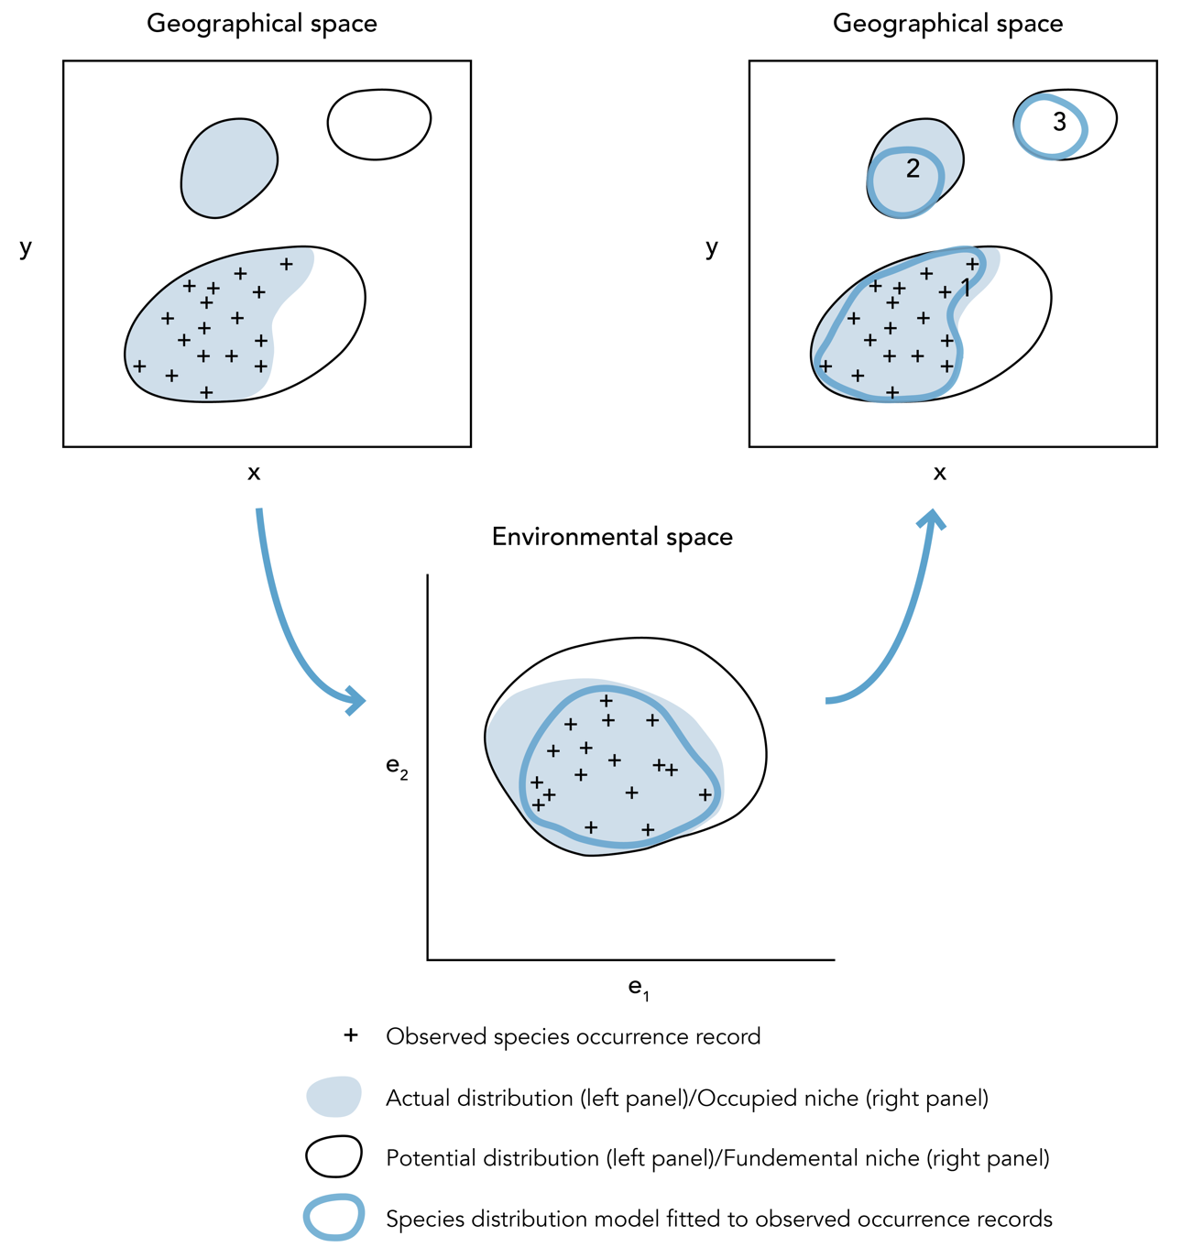

Figure 3. Diagram illustrating how a hypothetical species distribution model may be fitted to observed species occurrence records (using the same hypothetical case as in Figure 2). A modelling technique (e.g., GARP, Maxent) is used to characterize the species’ niche in environmental space by relating observed occurrence localities to a suite of environmental variables. Notice that, in environmental space, the model may not identify either the species’ occupied niche or fundamental niche; rather, the model identifies only that part of the niche defined by the observed records. When projected back into geographical space, the model will identify parts of the actual distribution and potential distribution. For example, the model projection labeled 1 identifies the known distributional area. Projected area 2 identifies part of the actual distribution that is currently unknown; however, a portion of the actual distribution is not predicted because the observed occurrence records do not identify the full extent of the occupied niche (i.e., there is incomplete sampling; see area D in Figure 2). Similarly, modeled area 3 identifies an area of potential distribution that is not inhabited (the full extent of the potential distribution is not identified because the observed occurrence records do not identify the full extent of the fundamental niche due to, for example, incomplete sampling, biotic interactions, or constraints on species dispersal; see areas D and E in Figure 2).

Uses of species distribution models

Consider modeled area 2 in Figure 3, which identifies part of the actual distribution for which no occurrence records have been collected. Although the model does not predict the full extent of the actual distribution, additional sampling in the area identified may yield new occurrence records. A number of studies have demonstrated the utility of species distribution modeling for guiding field surveys toward regions where there is an increased probability of finding new populations of a known species (Fleishman et al. 2003; Bourg et al. 2005; Guisan et al. 2006). Accelerating the discovery of new populations in this way may prove extremely useful for conservation planning, especially in poorly known and highly threatened landscapes.

Consider now predicted area 3 in Figure 3. Here, the model identifies an area of potential distribution that is environmentally similar to where the species is known to occur, but which is not inhabited. The full extent of the potential distribution is not predicted, but the model can be useful for identifying sites that may be suitable for reintroduction of a species (Pearce and Lindenmayer 1998) or sites where a species is most likely to become invasive (if it overcomes dispersal barriers and if biotic competition does not prevent establishment; Peterson 2003). Model predictions of this type also have the potential to accelerate the discovery of previously unknown species that are closely related to the modeled species and that occupy similar environmental space but different geographical space (Raxworthy et al. 2003).

Model predictions as illustrated in Figure 3 therefore have the potential to yield useful information, even though species are not expected to inhabit all suitable locations and sampling may be poor. Additional uses of species distribution modeling include identifying potential areas for disease outbreaks (Peterson et al. 2006), examining niche evolution (Peterson et al. 1999; Kozak and Wiens 2006) and informing taxonomy (Raxworthy et al. 2007). However, some potential applications require an estimation of the actual distribution of a species. For example, if a model is being used with the purpose of selecting priority sites for conservation, then an estimate of the actual species’ distribution is desired since it would be inefficient to conserve sites where the species is not present (Loiselle et al. 2003). In such cases, it should be remembered that modeled distributions represent environmentally suitable regions but do not necessarily correspond closely with the actual distribution. Additional processing of model output may be required to improve predictions of the actual distribution (Merow et al. 2022). For example, predicted areas that are isolated from observed occurrence records by a dispersal barrier may be removed (Peterson et al. 2002) and the influence of competing species may be incorporated (Anderson 2002; Kass et al. 2021; Merow et al. 2022).

It is useful to note that mechanistic distribution models (e.g., Chuine and Beaubien 2001; Kearney and Porter 2009) are subject to the same basic caveat as correlative approaches: the models aim to identify areas with suitable environmental conditions, but do not inform us which areas are actually occupied. Mechanistic models are ideally suited to identifying a species’ fundamental niche, and hence its potential distribution. This is because mechanistic approaches model physiological limitations in a species’ environmental tolerance, without relying on known occurrence records to define suitable environments. However, the detailed understanding of species’ physiology that is required to build mechanistic models prohibits their use in many instances.

The discussion in this section should help clarify the theoretical basis of the species distribution modeling approach. It is crucial that any application of these models has a sound theoretical basis and that model outputs are interpreted in the context of this framework (see Box 2). It should now be apparent why the terminology used to describe these models is so varied throughout the literature. The terms “ecological niche model,” “environmental niche model,” “bioclimate envelope model,” and “environmental suitability model” usually refer to attempts to estimate the potential distribution of a species. Use of the term “species distribution model” implies that the aim is to simulate the actual distribution of the species. Nevertheless, each of these terms refers to the same basic approach, which can be summarized as follows: 1) the study area is modeled as a raster map composed of grid cells at a specified resolution, 2) the dependent variable is the known species’ distribution, 3) a suite of environmental variables are collated to characterize each cell, 4) a function of the environmental variables is generated so as to classify the degree to which each cell is suitable for the species (Hirzel et al. 2002).

Box 2. Caution! On the use and misuse of models

Garbage in, garbage out: This old adage is as relevant to distribution modeling as it is to other fields. Put simply, a model is only as good as the data it contains. Thus, if the occurrence records used to build a correlative species distribution model do not provide useful information as to the environmental requirements of the species, then the model cannot provide useful output. If you put garbage into the model, you will get garbage out.

Model extrapolation: “Extrapolation” refers to the use of a model to make predictions for areas with environmental values that are beyond the range of the data used to calibrate (i.e., develop) the model. For example, suppose a distribution model was calibrated using occurrence records that spanned a temperature range of 10–20ºC. If the model is used to predict the species’ distribution in a different region (or perhaps under a future climate scenario) where the temperature reaches 25ºC, then the model is extrapolating. In this case, because the model has no prior information regarding the probability of the species’ occurrence at 25ºC, the prediction may be extremely uncertain (see Pearson et al. 2006). Model extrapolation should be treated with a great deal of caution.

The lure of complicated technology: Many approaches to modeling species’ distributions utilize complex computational technology (e.g., machine learning tools such as artificial neural networks and genetic algorithms) along with huge GIS (Geographic Information Systems) databases of digital environmental layers. In some cases, these approaches can yield highly successful predictions. However, there is a risk that model users will be swayed by the apparent complexity of the technology: “it is so complicated, it must be correct”! Always remember that a model can only be useful if the theoretical underpinnings on which it is based are sound. For additional discussion of the limitations of ecological models, see the NCEP module “Applications of Remote Sensing to Ecological Modeling” available in NCEP module collection at https://ncep.amnh.org.

References

Anderson, R.P. 2013. A framework for using niche models to estimate impacts of climate change on species distributions. Annals of the New York Academy of Sciences, Sep 1297(2013):8-28. https://doi.org/10.1111/nyas.12264.
Anderson, R.P., M. Gómez-Laverde, and A.T. Peterson. 2002. Geographical distributions of spiny pocket mice in South America: Insights from predictive models. Global Ecology and Biogeography 11(2):131–141. https://doi.org/10.1046/j.1466-822X.2002.00275.x.
Anderson, R.P., and E. Martı́nez-Meyer. 2004. Modeling species’ geographic distributions for preliminary conservation assessments: An implementation with the spiny pocket mice (Heteromys) of Ecuador. Biological Conservation 116(2):167–179. https://doi.org/10.1016/S0006-3207(03)00187-3.
Anderson, R.P., A.T. Peterson, and M. Gómez-Laverde. 2002. Using niche-based GIS modeling to test geographic predictions of competitive exclusion and competitive release in South American pocket mice. Oikos 98(1):3–16. https://doi.org/10.1034/j.1600-0706.2002.t01-1-980116.x.
Araújo, M.B., and M. Luoto. 2007. The importance of biotic interactions for modelling species distributions under climate change. Global Ecology and Biogeography 16(6):743–753. https://doi.org/10.1111/j.1466-8238.2007.00359.x.
Araújo, M.B., R.G. Pearson, and C. Rahbek. 2005b. Equilibrium of species’ distributions with climate. Ecography 28(5):693–695. https://www.jstor.org/stable/3683759.
Araújo, M.B., R.G. Pearson, W. Thuiller, and M. Erhard. 2005a. Validation of species–climate impact models under climate change. Global Change Biology 11(9):1504–1513. https://doi.org/10.1111/j.1365-2486.2005.01000.x.
Barbosa, F.G., F. Schneck, and A.S. Melo. 2012. Use of ecological niche models to predict the distribution of invasive species: A scientometric analysis. Brazilian Journal of Biology 72:821–829. https://doi.org/10.1590/S1519-69842012000500007.
Bett, N.N., M.E. Blair, and E.J. Sterling. 2012. Ecological niche conservatism in doucs (Genus Pygathrix). International Journal of Primatology 33(4):972–988. https://doi.org/10.1007/s10764-012-9622-3.
Blair, M.E., M.D. Le, and M. Xu. 2022. Species distribution modeling to inform transboundary species conservation and management under climate change: Promise and pitfalls. Frontiers of Biogeography 14(1). https://doi.org/10.21425/F5FBG54662.
Booth, T.H., H.A. Nix, J.R. Busby, and M.F. Hutchinson. 2014. bioclim: The first species distribution modelling package, its early applications and relevance to most current MaxEnt studies. Diversity and Distributions 20(1):1–9. https://doi.org/10.1111/ddi.12144.
Bourg, N.A., W.J. McShea, and D.E. Gill. 2005. Putting a cart before the search: Successful habitat prediction for a rare forest herb. Ecology 86(10):2793–2804. https://doi.org/10.1890/04-1666.
Chase, J.M., and M.A. Leibold. 2003. Ecological Niches: Linking Classical and Contemporary Approaches. University of Chicago Press, Chicago, IL, USA.
Chuine, I., and E.G. Beaubien. 2001. Phenology is a major determinant of tree species range. Ecology Letters 4(5):500–510. https://doi.org/10.1046/j.1461-0248.2001.00261.x.
Christin, S., É. Hervet, and N. Lecomte. 2019. Applications for deep learning in ecology. Methods in Ecology and Evolution 10(10):1632–1644. https://doi.org/10.1111/2041-210X.13256.
Deblauwe, V., et al. 2016. Remotely sensed temperature and precipitation data improve species distribution modelling in the tropics. Global Ecology and Biogeography 25(4):443–454. https://doi.org/10.1111/geb.12426.
Elith, J., et al. 2006. Novel methods improve prediction of species’ distributions from occurrence data. Ecography 29(2):129–151. https://doi.org/10.1111/j.2006.0906-7590.04596.x.
Elith, J., and J.R. Leathwick. 2009. Species distribution models: Ecological explanation and prediction across space and time. Annual Review of Ecology, Evolution, and Systematics 40(1):677–697. https://doi.org/10.1146/annurev.ecolsys.110308.120159.
Elith, J., S.J. Phillips, T. Hastie, M. Dudík, Y.E. Chee, and C.J. Yates. 2010. A statistical explanation of MaxEnt for ecologists. Diversity and Distributions 17(1):43–57. https://doi.org/10.1111/j.1472-4642.2010.00725.x.
Ferrier, S., G. Watson, J. Pearce, and M. Drielsma. 2002. Extended statistical approaches to modelling spatial pattern in biodiversity in northeast New South Wales. I. Species-level modelling. Biodiversity & Conservation 11(12):2275–2307. https://doi.org/10.1023/A:1021302930424.
Fleishman, E., R.M. Nally, and J.P. Fay. 2003. Validation tests of predictive models of butterfly occurrence based on environmental variables. Conservation Biology 17(3):806–817. https://doi.org/10.1046/j.1523-1739.2003.02113.x.
Franklin, J. 2010. Mapping Species Distributions: Spatial Inference and Prediction. Cambridge University Press, Cambridge, UK.
Gavrutenko, M., B.E. Gerstner, J.M. Kass, S.M. Goodman, and R.P. Anderson. 2021. Temporal matching of occurrence localities and forest cover data helps improve range estimates and predict climate change vulnerabilities. Global Ecology and Conservation 27:e01569. https://doi.org/10.1016/j.gecco.2021.e01569.
Gibbons, D.W., J.B. Reid, and R.A. Chapman. 1993. The New Atlas of Breeding Birds in Britain and Ireland: 1988-1991. Poyser, UK.
Graham, C.H., C. Moritz, and S.E. Williams. 2006. Habitat history improves prediction of biodiversity in rainforest fauna. Proceedings of the National Academy of Sciences 103(3):632–636. https://doi.org/10.1073/pnas.0505754103.
Graham, C.H., S.R. Ron, J.C. Santos, C.J. Schneider, and C. Moritz. 2004. Integrating phylogenetics and environmental niche models to explore speciation mechanisms in dendrobatid frogs. Evolution 58(8):1781–1793. https://doi.org/10.1111/j.0014-3820.2004.tb00461.x.
Guisan, A., O. Broennimann, R. Engler, M. Vust, N.G. Yoccoz, A. Lehmann, and N.E. Zimmermann. 2006. Using niche-based models to improve the sampling of rare species. Conservation Biology 20(2):501–511. https://doi.org/10.1111/j.1523-1739.2006.00354.x.
Guisan, A., T.C. Edwards, and T. Hastie. 2002. Generalized linear and generalized additive models in studies of species distributions: Setting the scene. Ecological Modelling 157(2–3):89–100. https://doi.org/10.1016/S0304-3800(02)00204-1.
Guisan, A., and W. Thuiller. 2005. Predicting species distribution: Offering more than simple habitat models. Ecology Letters 8(9):993–1009. https://doi.org/10.1111/j.1461-0248.2005.00792.x.
Hampe, A. 2004. Bioclimate envelope models: What they detect and what they hide. Global Ecology and Biogeography 13(5):469–471. https://www.jstor.org/stable/3697578.
Heikkinen, R.K., M. Luoto, R. Virkkala, R.G. Pearson, and J.-H. Körber. 2007. Biotic interactions improve prediction of boreal bird distributions at macro-scales. Global Ecology and Biogeography 16(6):754–763. https://doi.org/10.1111/j.1466-8238.2007.00345.x.
Higgins, S.I., D.M. Richardson, R.M. Cowling, and T.H. Trinder-Smith. 1999. Predicting the landscape-scale distribution of alien plants and their threat to plant diversity. Conservation Biology 13(2):303–313. https://doi.org/10.1046/j.1523-1739.1999.013002303.x.
Hirzel, A.H., J. Hausser, D. Chessel, and N. Perrin. 2002. Ecological-niche factor analysis: How to compute habitat-suitability maps without absence data? Ecology 83(7):2027–2036. https://doi.org/10.1890/0012-9658(2002)083[2027:ENFAHT]2.0.CO;2.
Hugall, A., C. Moritz, A. Moussalli, and J. Stanisic, J. 2002. Reconciling paleodistribution models and comparative phylogeography in the Wet Tropics rainforest land snail Gnarosophia bellendenkerensis (Brazier 1875). Proceedings of the National Academy of Sciences 99(9):6112–6117. https://doi.org/10.1073/pnas.092538699.
Huntley, B., P.M. Berry, W. Cramer, and A.P. McDonald. 1995. Special paper: Modelling present and potential future ranges of some European higher plants using climate response surfaces. Journal of Biogeography 22(6):967–1001. https://doi.org/10.2307/2845830.
Hutchinson, G.H. 1957. Concluding remarks. Cold Spring Harbor Symposium on Quantitative Biology 22:415–457.
Kass, J.M., S.I. Meenan, N. Tinoco, S.F. Burneo, and R.P. Anderson. 2021. Improving area of occupancy estimates for parapatric species using distribution models and support vector machines. Ecological Applications 31(1):e02228. https://doi.org/10.1002/eap.2228.
Kass J.M., et al. 2023. wallace 2: a shiny app for modeling species niches and distributions redesigned to facilitate expansion via module contributions. Ecography 2023(3):e06547. https://doi.org/10.1111/ecog.06547.
Kearney, M., and W. Porter. 2009. Mechanistic niche modelling: Combining physiological and spatial data to predict species’ ranges. Ecology Letters 12(4):334–350. https://doi.org/10.1111/j.1461-0248.2008.01277.x.
Kozak, K.H., and J. Wiens. 2006. Does niche conservatism promote speciation? A case study in North American salamanders. Evolution 60(12):2604–2621. https://doi.org/10.1111/j.0014-3820.2006.tb01893.x.
Lapeyrolerie, M., M.S. Chapman, K.E.A. Norman, and C. Boettiger. 2022. Deep reinforcement learning for conservation decisions. Methods in Ecology and Evolution 13(11):2649–2662. https://doi.org/10.1111/2041-210X.13954.
Lawton, J. 2000. Concluding remarks: A review of some open questions. Ecological Consequences of Heterogeneity. Pages 401–424 in M. Hutchings, E. John, and A.J.A. Stewart, editors. Cambridge University Press, Cambridge, UK.
Liu, C., P.M. Berry, T.P. Dawson, and R.G. Pearson. 2005. Selecting thresholds of occurrence in the prediction of species distributions. Ecography 28(3):385–393. https://doi.org/10.1111/j.0906-7590.2005.03957.x.
Liu, C., G. Newell, and M. White. 2016. On the selection of thresholds for predicting species occurrence with presence-only data. Ecology and Evolution 6(1):337–348. https://doi.org/10.1002/ece3.1878.
Loiselle, B.A., C.A. Howell, C.H. Graham, J.M. Goerck, T. Brooks, K.G. Smith, and P.H. Williams. 2003. Avoiding pitfalls of using species distribution models in conservation planning. Conservation Biology 17(6):1591–1600. https://doi.org/10.1111/j.1523-1739.2003.00233.x.
Lucas, T.C.D. 2020. A translucent box: Interpretable machine learning in ecology. Ecological Monographs 90(4):e01422. https://doi.org/10.1002/ecm.1422.
Manhães, A.P., R. Loyola, G.G. Mazzochini, G. Ganade, A.T. Oliveira-Filho, and A.R. Carvalho. 2018. Low-cost strategies for protecting ecosystem services and biodiversity. Biological Conservation 217:187–194. https://doi.org/10.1016/j.biocon.2017.11.009.
Merow, C., M.J. Smith, and J.A. Silander, Jr. 2013. A practical guide to MaxEnt for modeling species’ distributions: What it does, and why inputs and settings matter. Ecography 36(10):1058–1069. https://doi.org/10.1111/j.1600-0587.2013.07872.x.
Merow, C., et al. 2022. Operationalizing expert knowledge in species’ range estimates using diverse data types. Frontiers of Biogeography 14(2). https://doi.org/10.21425/F5FBG53589.
Musher, L.J., P.J. Galante, G. Thom, J.W. Huntley, and M.E. Blair. 2020. Shifting ecosystem connectivity during the Pleistocene drove diversification and gene-flow in a species complex of Neotropical birds (Tityridae: Pachyramphus). Journal of Biogeography 47(8):1714–1726. https://doi.org/10.1111/jbi.13862.
Nix, H.A. 1986. A biogeographic analysis of Australian elapid snakes. Pages 4–15 in R. Longmore, editor. Atlas of Elapid Snakes of Australia. Australian Flora and Fauna Series No. 7, Australian Government Publishing Service, Canberra, Australia.
Olden, J.D., J.J. Lawler, and N.L. Poff. 2008. Machine learning methods without tears: A primer for ecologists. The Quarterly Review of Biology 83(2):171–193. https://doi.org/10.1086/587826.
Pasetto, D. et al. 2018. Integration of satellite remote sensing data in ecosystem modelling at local scales: Practices and trends. Methods in Ecology and Evolution 9(8):1810–1821. https://doi.org/10.1111/2041-210X.13018.
Paz, A., T.S. Silva, and A.C. Carnaval. 2022. A framework for near-real time monitoring of diversity patterns based on indirect remote sensing, with an application in the Brazilian Atlantic rainforest. PeerJ 10:e13534. https://doi.org/10.7717/peerj.13534.
Pearce, J., and D. Lindenmayer. 1998. Bioclimatic analysis to enhance reintroduction biology of the endangered helmeted honeyeater (Lichenostomus melanops cassidix) in Southeastern Australia. Restoration Ecology 6(3):238–243. https://doi.org/10.1046/j.1526-100X.1998.00636.x.
Pearson, R.G., and T.P. Dawson. 2003. Predicting the impacts of climate change on the distribution of species: Are bioclimate envelope models useful? Global Ecology and Biogeography 12(5):361–371. https://doi.org/10.1046/j.1466-822X.2003.00042.x.
Pearson, R.G., C.J. Raxworthy, M. Nakamura, and A. Townsend Peterson. 2007. Predicting species distributions from small numbers of occurrence records: a test case using cryptic geckos in Madagascar. Journal of Biogeography 34(1):102–117. https://doi.org/10.1111/j.1365-2699.2006.01594.x.
Peters, D.P.C., K.M. Havstad, J. Cushing, C. Tweedie, O. Fuentes, and N. Villanueva- Rosales. 2014. Harnessing the power of big data: Infusing the scientific method with machine learning to transform ecology. Ecosphere 5(6):art67. https://doi.org/10.1890/ES13-00359.1.
Peterson, A.T. 2003. Predicting the geography of species’ invasions via ecological niche modeling. The Quarterly Review of Biology 78(4):419–433. https://doi.org/10.1086/378926.
Peterson, A.T., B.W. Benz, and M. Papeş. 2007. Highly pathogenic H5N1 avian influenza: Entry pathways into North America via bird migration. PLOS ONE 2(2):e261. https://doi.org/10.1371/journal.pone.0000261.
Peterson, A.T., R.R. Lash, D.S. Carroll, and K.M. Johnson. 2006. Geographic potential for outbreaks of Marburg hemorrhagic fever. American Journal of Tropical Medicine & Hygiene 75:9–15.
Peterson, A.T., M.A. Ortega-Huerta, J. Bartley, V. Sánchez-Cordero, J. Soberón, R.H. Buddemeier, and D.R.B. Stockwell. 2002. Future projections for Mexican faunas under global climate change scenarios. Nature 416(6881):Article 6881. https://doi.org/10.1038/416626a.
Peterson, A.T., J. Soberón, R.G. Pearson, R.P. Anderson, E. Martínez-Meyer, M. Nakamura, and M.B. Araújo. 2011. Ecological niches and geographic distributions (MPB-49). Princeton University Press, Princeton, NJ, USA.
Peterson, A.T., J. Soberón, and V. Sánchez-Cordero. 1999. Conservatism of ecological niches in evolutionary time. Science 285(5431):1265–1267.
Phillips, S.J., R.P. Anderson, and R.E. Schapire. 2006. Maximum entropy modeling of species geographic distributions. Ecological Modelling 190(3–4):231–259. https://doi.org/10.1016/j.ecolmodel.2005.03.026.
Pulliam, H.R. 2000. On the relationship between niche and distribution. Ecology Letters 3(4):349–361. https://doi.org/10.1126/science.285.5431.1265.
Raxworthy, C., C. Ingram, and R. Pearson. 2007. Species delimitation applications for ecological niche modeling: A review and empirical evaluation using Phelsuma day gecko groups from Madagascar. Systematic Biology 56(6):907–923. https://doi.org/10.1080/10635150701775111.
Raxworthy, C J., E. Martinez-Meyer, N. Horning, R.A. Nussbaum, G.E. Schneider, M.A. Ortega-Huerta, and A. Townsend Peterson. 2003. Predicting distributions of known and unknown reptile species in Madagascar. Nature 426(6968):Article 6968. https://doi.org/10.1038/nature02205.
Srivastava, V. 2019. Species distribution models (SDM): Applications, benefits and challenges in invasive species management. CAB Reviews: Perspectives in Agriculture, Veterinary Science, Nutrition and Natural Resources:14(020). https://doi.org/10.1079/PAVSNNR201914020.
Stanton, J.C., K.T. Shoemaker, R.G. Pearson, and H.R. Akçakaya. 2015. Warning times for species extinctions due to climate change. Global Change Biology 21(3):1066–1077. https://doi.org/10.1111/gcb.12721.
Thuiller, W., D.M. Richardson, P. Pyšek, G.F. Midgley, G.O. Hughes, and M. Rouget. 2005. Niche‐based modelling as a tool for predicting the risk of alien plant invasions at a global scale. Global Change Biology 11(12):2234–2250.
Trinh-Dinh, H., A.T. Nguyen, M.D. Le, X. Li, N.T.H. Cao, and M.E. Blair. 2022. Assessment of climate change impacts on one of the rarest apes on Earth, the Cao Vit Gibbon Nomascus nasutus. Frontiers of Biogeography 14(1). https://doi.org/10.21425/F5FBG53320.
Valavi, R., G. Guillera‐Arroita, J.J. Lahoz‐Monfort, and J. Elith. 2022. Predictive performance of presence‐only species distribution models: a benchmark study with reproducible code. Ecological Monographs 92(1):e01486. https://doi.org/10.1002/ecm.1486.
Villero, D., M. Pla, D. Camps, J. Ruiz-Olmo, and L. Brotons. 2017. Integrating species distribution modelling into decision-making to inform conservation actions. Biodiversity and Conservation 26(2):251–271. https://doi.org/10.1007/s10531-016-1243-2.
Woodward, F.I., and D.J. Beerling. 1997. The dynamics of vegetation change: Health warnings for equilibrium “dodo” models. Global Ecology and Biogeography Letters 6(6):413–418. https://doi.org/10.2307/2997350.

i Pace University, Pleasantville-Briarcliff Campus, Environmental Studies and Science, Pleasantville, NY, USA
ii Department of Environmental Systems Science, Institute of Integrative Biology, ETH Zürich, Switzerland
iii City College of the City University of New York, Biology, New York, NY, USA
iv Center for Biodiversity and Conservation, American Museum of Natural History, New York, NY, USA
v University College London, London, UK

